1a.

> stress

Subject Group PSSbefore PSSafter

1 A1 Sport 25 13

2 A3 Sport 17 15

3 A4 Sport 12 13

4 A5 Sport 21 22

5 A6 Sport 29 25

6 A7 Sport 28 24

7 A8 Sport 21 19

8 B1 Sport 18 19

9 B2 Sport 20 24

10 B3 Sport 29 21

11 B4 Sport 27 22

12 B5 Sport 44 33

13 B6 Sport 23 8

14 B7 Sport 18 12

15 B8 Sport 27 30

16 A2 Control 0 16

17 C1 Control 30 27

18 C2 Control 12 31

19 C3 Control 29 21

20 C4 Control 25 33

21 C6 Control 2 9

22 C7 Control 6 26

23 C8 Control 20 20

24 C9 Control 27 28

25 C10 Control 14 21

26 C11 Control 15 29

1b.

> head(stress,6)

Subject Group PSSbefore PSSafter

1 A1 Sport 25 13

2 A3 Sport 17 15

3 A4 Sport 12 13

4 A5 Sport 21 22

5 A6 Sport 29 25

6 A7 Sport 28 24

1c.

> tail(stress,6)

Subject Group PSSbefore PSSafter

21 C6 Control 2 9

22 C7 Control 6 26

23 C8 Control 20 20

24 C9 Control 27 28

25 C10 Control 14 21

26 C11 Control 15 29

1.d  
  
> stress$Differences<-stress$PSSafter-stress$PSSbefore

> stress

Subject Group PSSbefore PSSafter Differences

1 A1 Sport 25 13 -12

2 A3 Sport 17 15 -2

3 A4 Sport 12 13 1

4 A5 Sport 21 22 1

5 A6 Sport 29 25 -4

6 A7 Sport 28 24 -4

7 A8 Sport 21 19 -2

8 B1 Sport 18 19 1

9 B2 Sport 20 24 4

10 B3 Sport 29 21 -8

11 B4 Sport 27 22 -5

12 B5 Sport 44 33 -11

13 B6 Sport 23 8 -15

14 B7 Sport 18 12 -6

15 B8 Sport 27 30 3

16 A2 Control 0 16 16

17 C1 Control 30 27 -3

18 C2 Control 12 31 19

19 C3 Control 29 21 -8

20 C4 Control 25 33 8

21 C6 Control 2 9 7

22 C7 Control 6 26 20

23 C8 Control 20 20 0

24 C9 Control 27 28 1

25 C10 Control 14 21 7

26 C11 Control 15 29 14

1ei.  
> stress$Differences

[1] -12 -2 1 1 -4 -4 -2 1 4 -8 -5 -11 -15

[14] -6 3 16 -3 19 -8 8 7 20 0 1 7 14

1eii.  
> mean(stress$Differences)

[1] 0.8461538

> sd(stress$Differences)

[1] 9.194313

1eiii.  
> summary(stress$Differences)

Min. 1st Qu. Median Mean 3rd Qu. Max.

-15.0000 -4.7500 0.5000 0.8462 6.2500 20.0000

1eiv.  
> hist(stress$Differences)

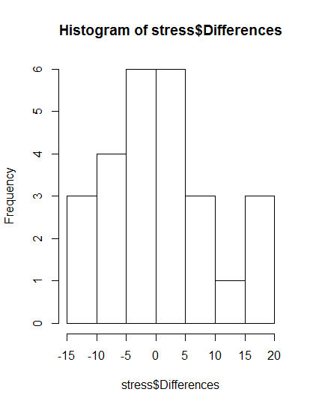  
  
  
  
  
  
  
  
  
  
  
  
  
  
  
  
  
1ev.  
boxplot(stress$Differences)

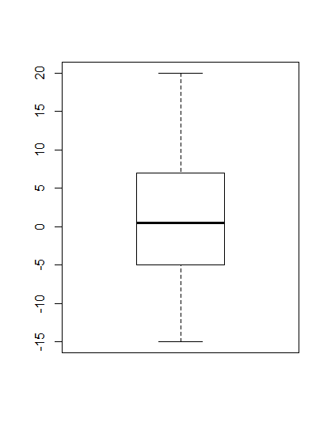

2. The data is fairly symmetric and unimodal, other than the spike in the histogram between 15 and 20. The mean of all groups of 0.85 indicates that the data is centered at 0, which suggests no change, however this analysis didn’t look at separating the excursive and control groups. Looking at the differences for those groups, almost all the exercise groups have a negative difference, and almost all the control groups are positive, so there may be a difference overall, but more study would be needed to see if the difference is statistically significant.